Cathryn Jirlds | Photographer  Leland, NC
Artist Biography

Through my photography, I enjoy showcasing the world around me through a different perspective—a different lens, if you will. I often put these images into collected works to explore all aspects of the subject I find fascinating! I have collections of intimate flowers, the decline of small family tobacco farming, Carolina Sandhills prescribed burns, stunning southwest landscapes, and my latest passion, shipscapes.

As seen through the camera viewfinder, you will be surprised by the art found on ship hulls in my most recent creative images, whether life-like pictures or abstract views. I approached this exhibit as I do others: First, I find an intimate view of subjects of interest to dive in for a more in-depth view and open my imagination. Second, I am drawn to dramatic colors and shapes, either abstract detail or tightly focused point-of-view images to give the observer a different perspective.

I find great inspiration in the work of famed American painter Georgia O’Keeffe, known for capturing portions of subjects, especially bright blossoms and southwestern landscapes. Two of her quotes speak directly to me and, I hope, to the work I create:

“I often painted fragments of things because it seemed to make my statement as well as or better than the whole could.”

“I found I could say things with color and shapes that I couldn’t say any other way – things I had no words for”

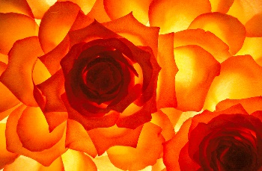 | 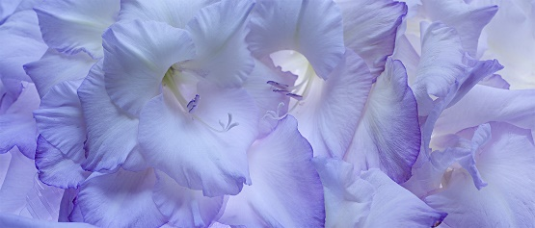 | 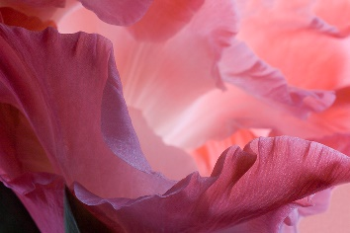 | 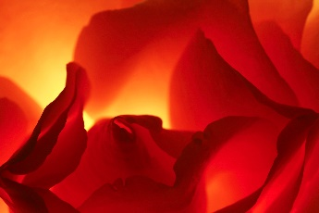
Artspace, Raleigh, Seeing Roses, First Place, Raleigh Rose Society Award, for best representation of modern roses.

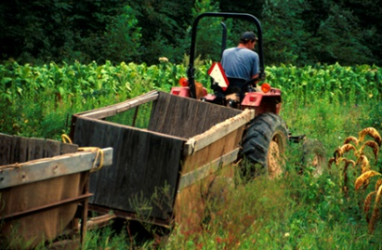 | 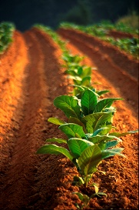 | 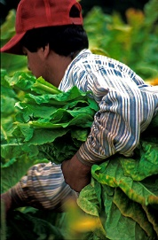 | 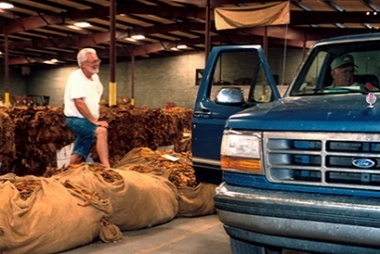
Last Generation: Our Vanishing Southern Heritage is a 30-piece photo documentary from seedlings to auction.

1999: Certification in Documentary Studies from the Center for Documentary Studies at Duke University.
1999-2010: Travel photographs published in magazines and newspapers from Philadelphia to Austin.

Member: Art League of Leland and Wilmington Art Association

